Step 1- Created New Job – named Job 2

Step 2- mentioned the master node this time because master is going to sign the puppet-agent certificate.

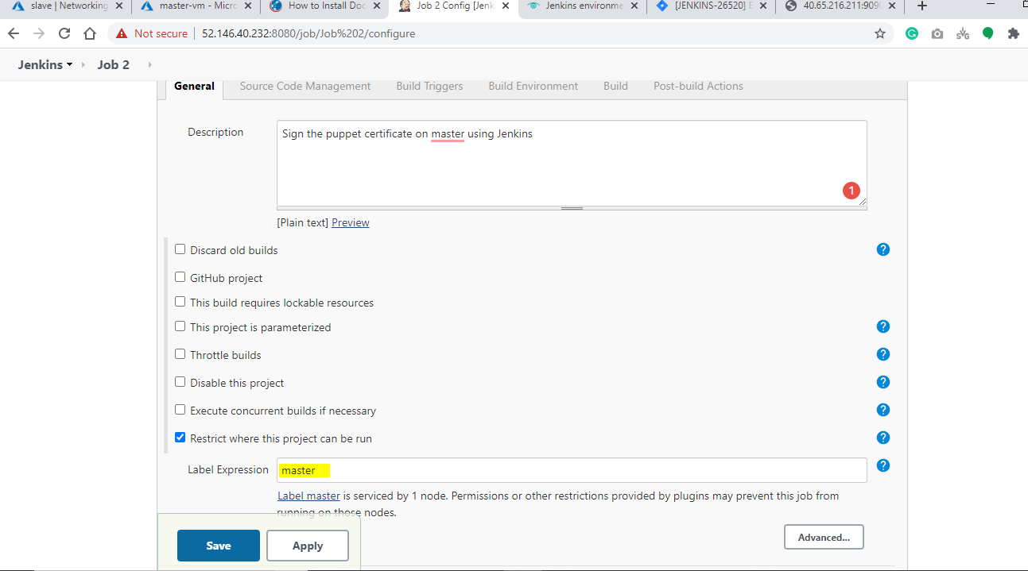

Step 3-In Build section , written some command to sign the puppet-agent certificate.

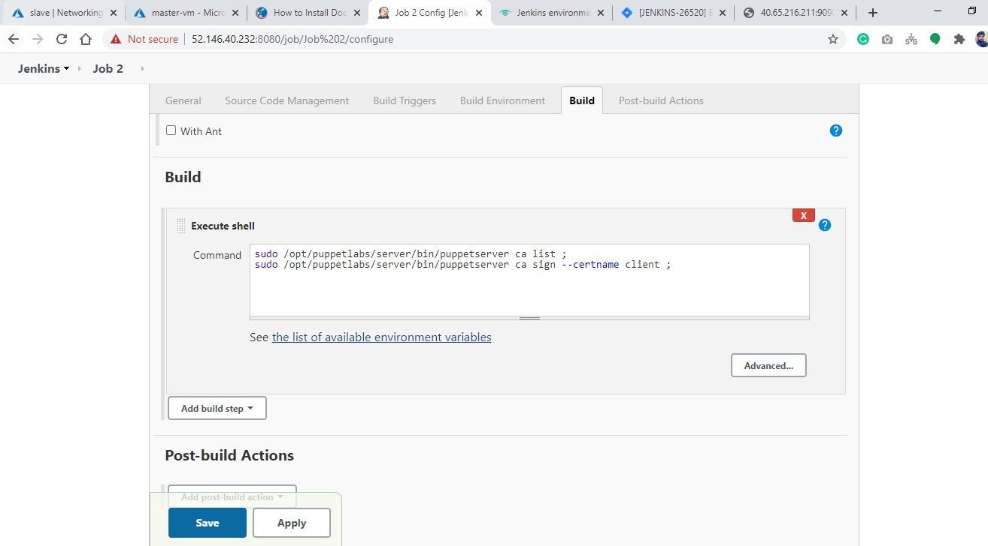

Log snapshot –

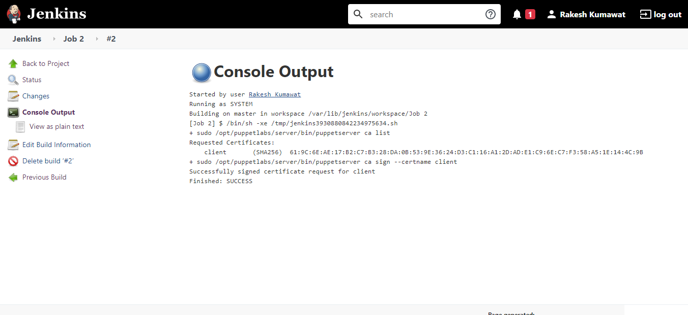

Currently we have only one puppet-agent so I have written the hardcoded pupprt-agent name but if there is more than one agent then I can use

/opt/puppetlabs/server/bin/puppetserver ca sign all

Note – Attached the log file in Build log folder.